OBSTACLE AVOIDING CAR with BLUETOOTH and ULTRASON 

**I.B.U ATM**

**Group Members: 3**

**Name and Id**

**Ishma Hafeez 21k-4688**

**Bilal Abdul 21K- 4522**

**Umer Naeem 21K-4927**

**Submitted to: Sumaiyah@nu.edu.pk**

**Teacher Name**

**Sumaiyah Zahid**

**Introduction**

**We are planning to create a virtual ATM which will allow the user to.**

**Goal**

**Our goal is to successfully implement a virtual atm system that allows registered users to access their bank status efficiently and make the necessary updates.**

**Description**

**List of Features**

* **Display current balance**
* **Withdraw cash**
* **Deposit cash**
* **Reset pin and verify using previous pin**
* **Reset Phone number and verify using previous phone number**
* **Authenticating user**
* **Managing user records**

**Tools & Techniques**

**Language used : C**

**IDE: DEV C++,Visual Studio**

**Code**

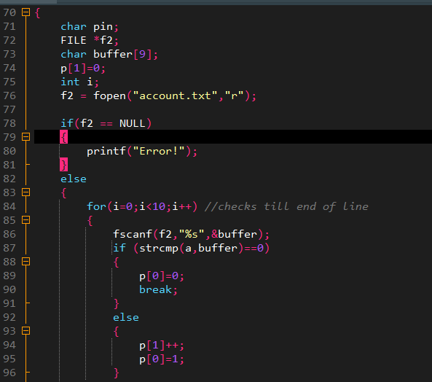

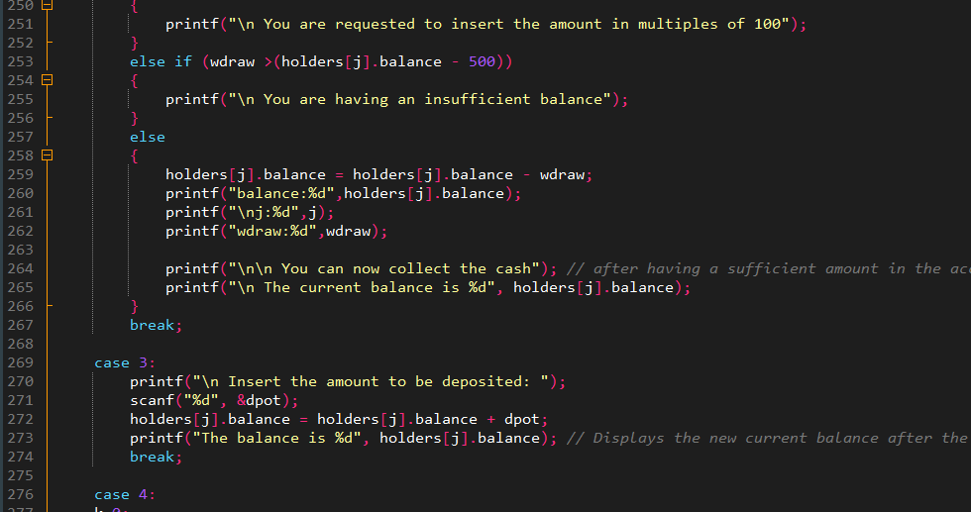

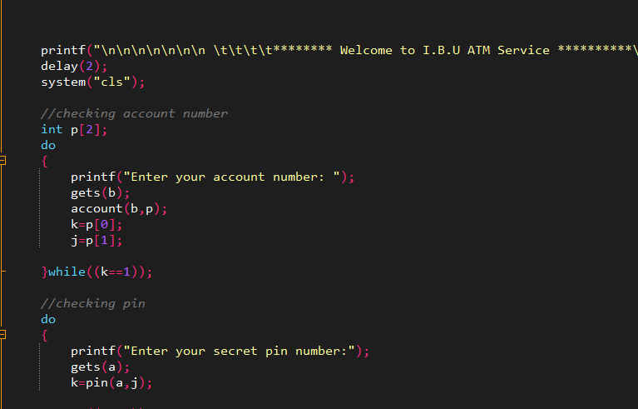

**Output Screenshots**

